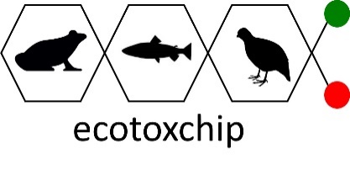
POSITION ANNOUNCEMENT
RESEARCH TECHNICIAN
Toxicology Centre, University of Saskatchewan

POSITION:
A full-time research technician position in toxicogenomics and molecular toxicology is available as part of a collaborative project with Drs. Markus Hecker and Natacha Hogan at the Toxicology Centre on the U of S campus. The successful candidate will be required to start a year-long contract in March 2020. There will be a possibility for extension based on adequate work performance and availability of funding. The position is out-of-scope of any bargaining unit.

QUALIFICATIONS:
- Completed an undergraduate or graduate degree in toxicology, biology, or in a related area OR a technical diploma with experience in molecular biological techniques
- Basic understanding of molecular biology and related techniques such as RT-PCR
- Have at least one year of experience working in a research laboratory
- Must be detail-orientated, dependable, organized, and responsible
- Must be able to manage time effectively to prioritize one’s own work
- Must have excellent interpersonal skills and the ability to work in a highly collaborative work environment

RESPONSIBILITIES & EXPECTATIONS:
- Preparation of animal tissues for extraction of RNA or proteins
- Perform RT-PCR assays
- Meticulous record keeping of sample processing, analysis and data management related to experiments
- Provide cleanliness and organization to the research area
- Maintenance of instruments on a regular basis to ensure proper functioning
- Organizing and performing proper decontamination and waste disposal procedures
- Interaction and coordination with staff and students in the Hecker and Hogan labs
- Provide assistance for other experiments when necessary

SALARY:
Commensurate with education and experience

DEADLINE:
Applications will be accepted until February 28th, 2020 or until a suitable candidate is found.

TO APPLY:
Applications must include the following three components:
- Cover Letter
- Résumé or Curriculum Vitae
- References (3)
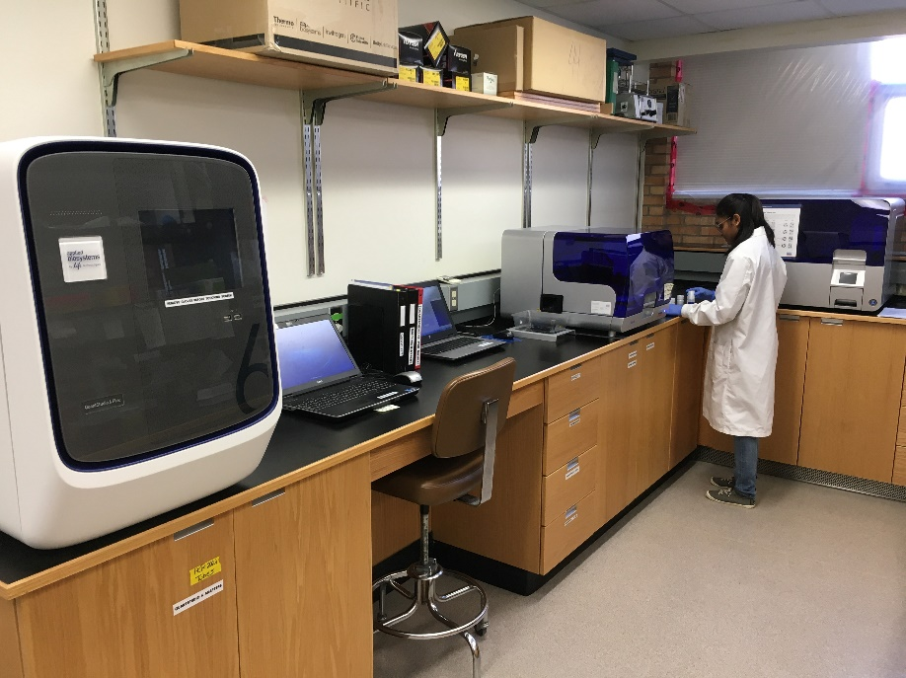
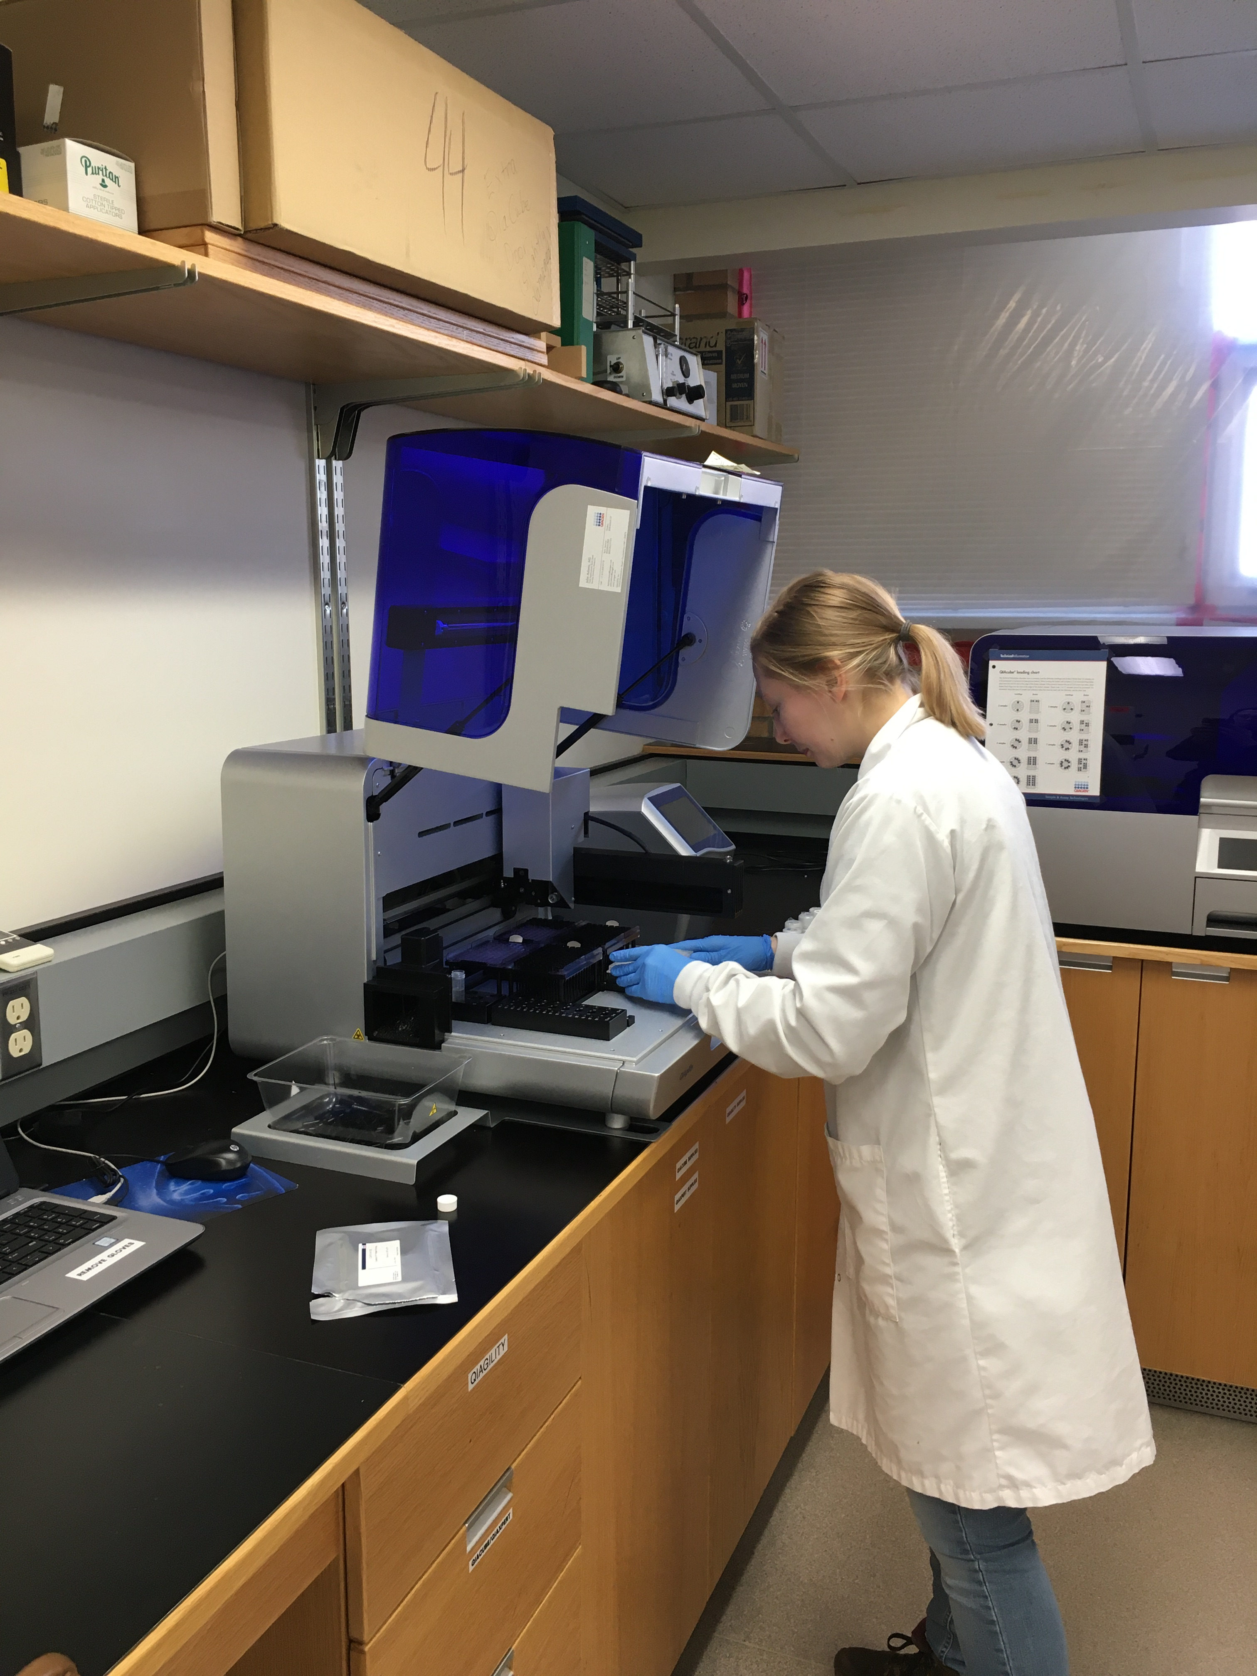Please send applications via email to Anita Massé at anita.masse@usask.ca

